**Date 26/Sep/24**

**Syed Najaf Ali 27662**

**Working Credit Hours 3:40 PM – 7:50 PM**

**Eye Diseases**

**What is a Cataracts?**

A cataract is the clouding of the lens inside the eye which **causes decreased light reaching the retina and results in a decrease in vision**. The lens is located behind your iris inside your eye.

Cataracts can affect different areas of the lens and can be classified accordingly.  The location and extent of the cataract also determines the extent of the vision impairment e.g**. if the center of the lens is affected, vision may be significantly impaired**, however, if the edges of the lens are affected, vision impairment may be barely noticeable.

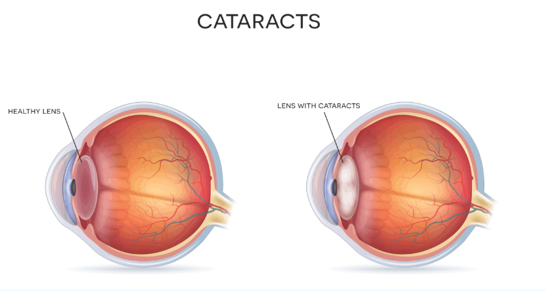

**Types of Cataracts**

* Age-related cataracts
* Secondary cataracts
* Traumatic cataracts [Reference 1](https://wefixeyes.co.nz/conditions/cataracts/)
* Congenital cataracts
* Toxic Cataracts

**How common is Cataracts ?**

Cataracts is a common age-related eye issue **mainly occur after 60 years of age.** **Cataract remains the leading cause of blindness worldwide, accounting for nearly half (47.8% or 17.7 million) of all blindness .**1 The treatment for cataract is surgical, a highly cost‐effective intervention, with excellent prognosis for sight restoration. There has been an international drive (VISION 2020: the Right to Sight) to increase cataract surgical services in order to reduce the cataract “backlog”. It is estimated that **globally approximately 15 million 2 cataract operations are performed annually, an increase of 5 million from only 5 years ago. (WHO).** The population is concentrated in the fertile Indus valley, whereas in most parts of Balochistan the population density is low. In this paper, findings from the Pakistan National Blindness and Visual Impairment Survey are reported with respect to the prevalence and magnitude of visual loss caused by cataract, the CSC, and barriers to the uptake of cataract services.

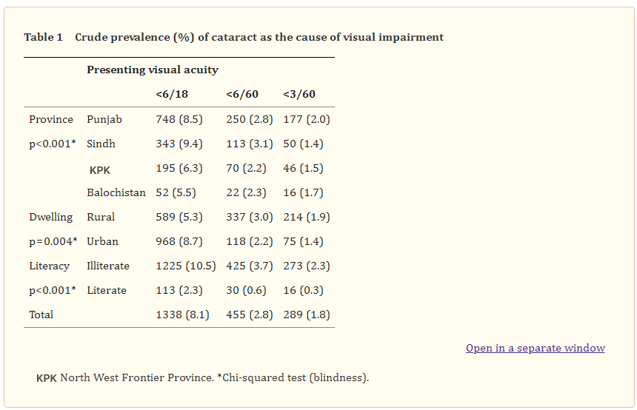

**Symptoms of Cataracts** [PMC Article Reference](https://www.ncbi.nlm.nih.gov/pmc/articles/PMC2001008/)

The symptoms experienced by those with cataracts are highly dependent on the location and severity of the cataracts. In some early stages, there may be no noticeable symptoms or vision changes in the early stages of a cataract. Symptoms of cataracts can include

* Blurring of vision – you may notice a film or haze in your everyday vision. This makes images look cloudy, blurry, fuzzy, foggy or filmy
* Change in color vision – colors may appear duller than before
* A noticeable cloudiness in the pupil
* Veiling Glare – increased difficulty with bright lights due to the cataract scattering the lights e.g. headlights when driving and bright sun light .

**Causes of Cataracts?**

**Age-related cataracts**. Mainly occur after 60 years of age.

**Secondary cataracts**. Occur as the result of another medical condition such as diabetes, an inflammatory eye condition such as uveitis, or an inflammatory skin condition such as eczema.

**Traumatic cataracts**. Occur as the result of an injury to the eye or lens.

**Congenital cataracts**. Are present at birth or develop in early childhood. They may be caused by an illness or infection in the mother during pregnancy, or as the result of a genetic defect.

**Toxic Cataracts** .Can result from chemical toxicity or long-term use of some medications, such as corticosteroids (eg: prednisone).

**Cataracts risk factors**

**Certain factors can increase the risk of developing a cataract**

* Aging
* Diabetes (cataracts can form earlier if you have diabetes)
* High blood pressure (hypertension and very low blood pressure (hypotension)
* Family history of cataracts at a young age
* Years of excessive exposure to the sun and UV rays
* Past eye injury or inflammation [Stanford health care Reference](https://stanfordhealthcare.org/medical-conditions/eyes-and-vision/cataract/risk-factors.html)

**How is cataracts diagnosed?**

If cataracts are suspected, a referral to an eye specialist is usually recommended. The eye specialist may carry out more detailed examinations of the eye and vision in order to determine the exact location and extent of the cataracts. They will then recommend appropriate treatment

Cataracts are detected through a comprehensive eye exam that includes.

* **Visual acuity test** - This eye chart test measures how well you see at various distances.
* **Dilated eye exam -** Drops are placed in your eyes to widen, or dilate, the pupils. Your eye care professional uses a special magnifying lens to examine your retina and optic nerve for signs of damage and other eye problems. After the exam, your close-up vision may remain blurred for several hours.

[Stanford medicine Reference](https://stanfordhealthcare.org/medical-conditions/eyes-and-vision/cataract/diagnosis.html)

**What is a Drusen?**

Drusen (singular: druse) are small yellow deposits of protein and lipids (fat) that develop under the retina. The retina is the light-sensitive nerve tissue at the back of the eye. The presence of many small and larger drusen is often an early sign of age-related macular degeneration (AMD).

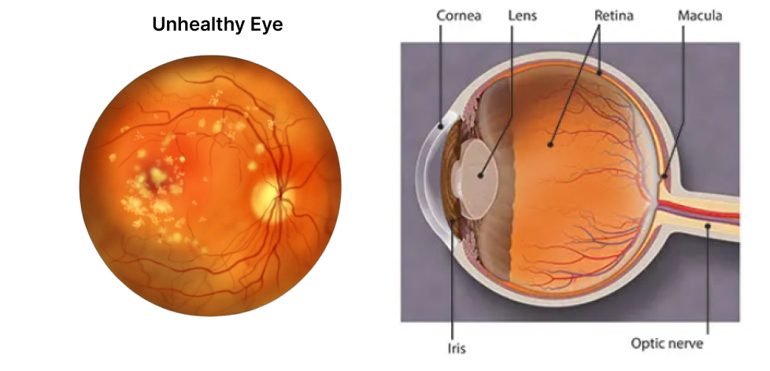

**Types of Drusen**

* Hard Drusen
* Soft Drusen

[Reference Article by Dr. Melody Huang, O.D.](https://www.visioncenter.org/conditions/drusen/)

**How common is Drusen ?**

Drusen numbers and size increased significantly with increasing age, as would be anticipated. However,**subjects in age-group four (45–54 years) demonstrated a decrease in number of drusen compared with the age category 36–44 years.** This could have been due to the nature of the sample, which was opportunistically selected from subjects attending optometry practices. While some participants likely attended for **advice on ophthalmic problems other than refractive issues, it is likely that those aged 18–44 had refractive errors**. In contrast 45–54 year olds may have been attending for the first time with presbyopic symptoms and may have been emmetropic.

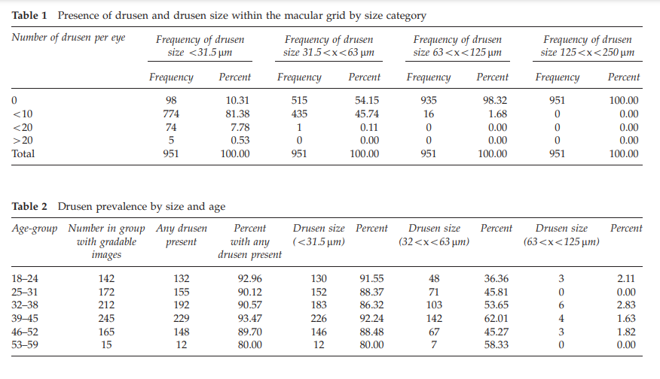

[Reference Article](https://www.nature.com/articles/eye2012165)

**Symptoms of Drusen**

Most people with drusen don’t show symptoms. It’s often detected during a routine eye exam. A few small drusen aren’t a sign of eye disease. However, many small and large or medium-sized drusen are early signs of dry macular degeneration.

Symptoms of dry macular degeneration include:

* Difficulty seeing when transitioning from bright light to low light
* A blank or blurry spot in your central vision

**Causes of Drusen?**

Drusen occurs naturally with age. It results from accumulating proteins, lipids, and other unwanted material in the retina. Usually, the retinal cells dump waste material for the immune system (macrophages) to clean up. If there’s excess waste or impaired macrophage function, the “garbage” can pile up, appearing like yellow-colored spots under the retina.

**Who Is at Risk for Drusen?**

**Drusen are commonly found in people over age 50.** Caucasian people are more likely to develop drusen and age-related macular degeneration**.**

* Presence of cardiovascular disease
* High blood cholesterol levels
* Smoking tobacco products

**How is Drusen diagnosed?**

An ophthalmologist can find and diagnose drusen during a dilated eye exam. First, they’ll dilate (enlarge) your pupils by administering dilating eye drops. Pupil dilation allows your doctor to examine a larger area of your retina. If large drusen are confirmed, your ophthalmologist will check your eyes for any symptoms of macular degeneration. They will use anAmsler grid, a checkerboard-like pattern of straight lines. The lines may appear wavy or missing if you have intermediate to advanced-stage AMD. Large drusen may indicate dry or wet macular degeneration. In this case, your doctor will administer the appropriate AMD treatment.

[Reference Article](https://www.nature.com/articles/eye2012165)

**What is a Age-Related Macular Degeneration (AMD)?**

Age-related macular degeneration (AMD) is a **disease that affects a person’s central vision**. Age-related macular degeneration is **the most common cause of severe loss of eyesight among people 50 and older.** Only the center of vision is affected with this disease. It is important to realize that people rarely go blind from it.

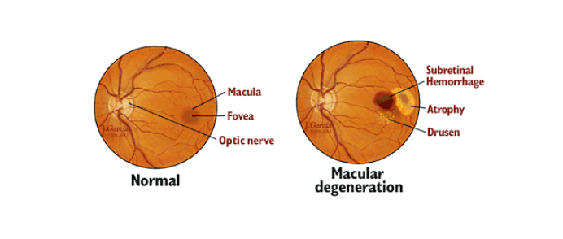

## Types of Age-Related Macular Degeneration

* Dry
* Wet

**Causes**

The two primary types of age-related macular degeneration have different causes.

**Dry:** This type is the most common. About 80% of those with AMD have the dry form. Its exact cause is unknown, although both genetic and environmental factors are thought to play a role. This happens as the light-sensitive cells in the macula slowly break down, generally one eye at a time. The loss of vision in this condition is usually slow and gradual. It is believed that the age-related damage of an important support membrane under the retina contributes to dry age-related macular degeneration.

**Wet:** Though this type is less common, it usually leads to more severe vision loss in patients than dry AMD. It is the most common cause of severe loss of vision. Wet AMD happens when abnormal blood vessels start to grow beneath the retina. They leak fluid and blood — hence the name wet AMD — and can create a large blind spot in the center of the visual field.

## Risk Factors

## There are several risk factors that can contribute to developing age-related macular degeneration, including:

* Being 50 and older
* Eating a diet high in saturated fat
* Smoking

**Age-Related Macular Degeneration Symptoms**

The following are the most common symptoms of age-related macular degeneration. However, each individual may experience symptoms differently. Symptoms may include:

* Straight lines appear wavy
* Difficulty recognizing familiar faces
* A dark, empty area or blind spot appears in the center of vision
* Blurry or fuzzy vision
* Loss of central vision, which is necessary for driving, reading, recognizing faces and performing close-up work.

## Age-Related Macular Degeneration Diagnosis

## In addition to a complete medical history and eye exam, your eye doctor may do the following tests to diagnose age-related macular degeneration

* **Visual acuity test**. This common eye chart test measures vision ability at various distances.
* **Pupil dilation**. The pupil is widened with eye-drops to allow a close-up examination of the eye’s retina.
* **Fluorescein angiography**. Used to detect wet age-related macular degeneration, this diagnostic test involves a special dye injected into a vein in the arm. Pictures are then taken as the dye passes through the blood vessels in the retina, helping the doctor evaluate if the blood vessels are leaking and whether or not the leaking can be treated.
* **Amsler grid.** Used to detect wet age-related macular degeneration, this test uses a checker board like grid to determine if the straight lines in the pattern appear wavy or missing to the patient. Both indications may signal the possibility of age-related macular degeneration.

## [Reference Hopkins Medicine USA](https://www.hopkinsmedicine.org/health/conditions-and-diseases/agerelated-macular-degeneration-amd#:~:text=Age%2Drelated%20macular%20degeneration%20(AMD)%20is%20a%20disease%20that,diet%20high%20in%20saturated%20fat.)